Ring Topology

->Each node is linked with its neighbour to form a closed network

->this configuration sees the data move from one node to another , either unidirectional or bidirectional

->this topology is used in small networks

->a token is transferred from one device to the next devise only the node with token can transmit data

Step 1:

First we have to place switch

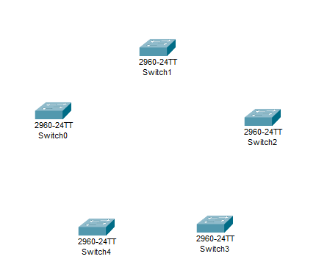

Step 2:

Then place pc beside the all switch and attach them with copper straight-Though

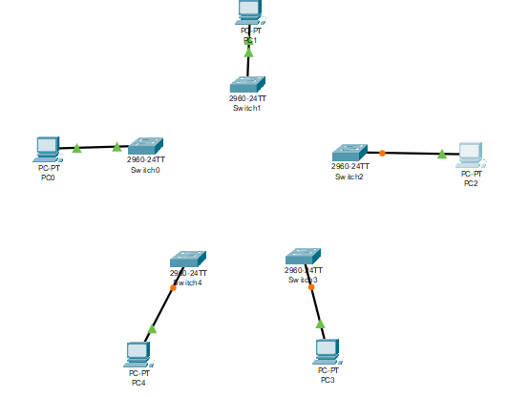

Step 4 :

Now connect all switch with each other and it closed loop with copper cross-over

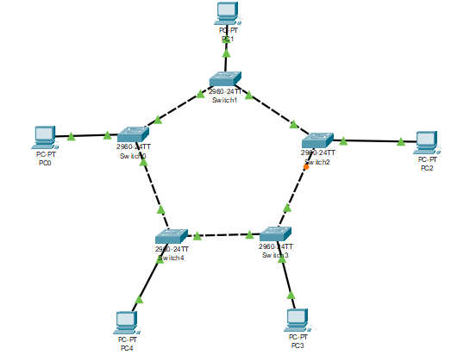

Step 5:

In step 5 we assigning a ip address for pc0,pc1,pc2,pc3 and pc4 of class c ip address

Pc0

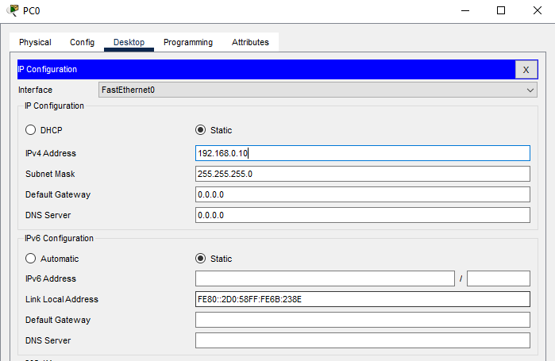

Pc 1

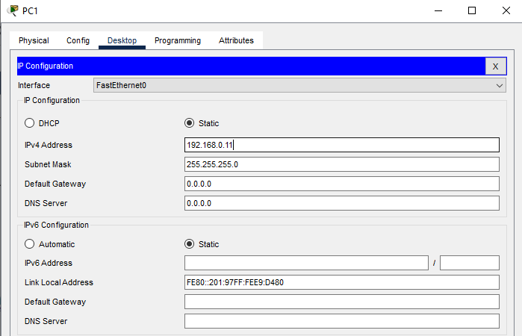

Pc 2

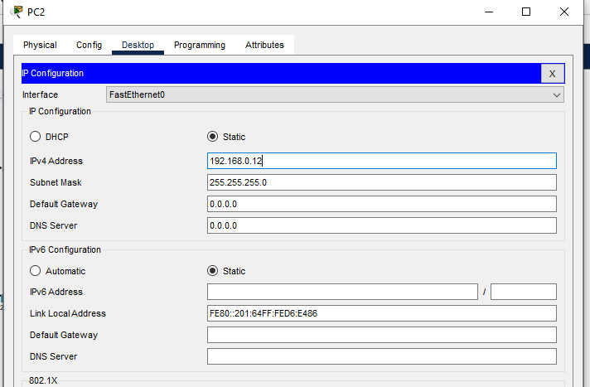

Pc 3

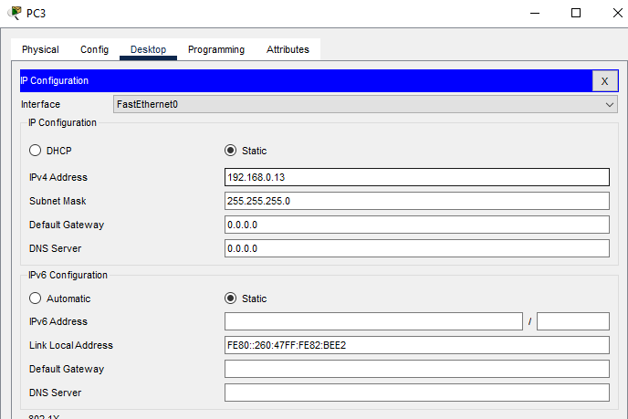

Pc4

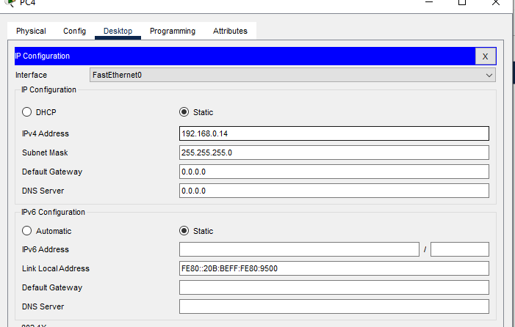

Ring topology

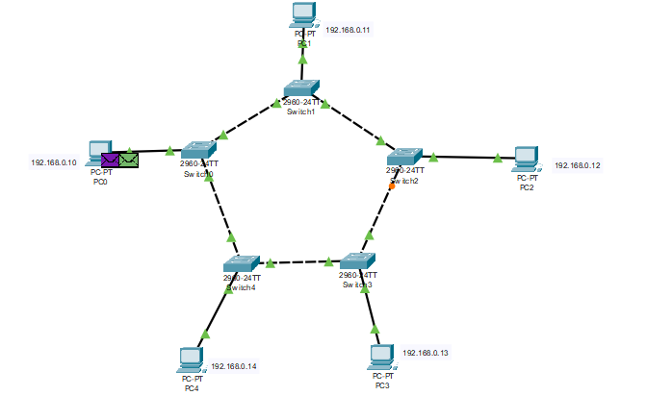

Advantages of Ring topology:

->if one device doesn’t receive a signal within a specified period it can issue an alarm

->the alarm alert’s the network operator to the problem and its location

Disadvantages of Ring topology:

->unidirectional traffic can be a dis advantage

->a break in ring can disabled the entire network